



**YEAR 12 CHEMISTRY**

**ORGANIC CHEMISTRY TEST**

This test consists of three sections

Section one: 20 Multiple choice questions (20 marks)

Section two: 5 Short answer questions (20 marks)

Section three: 1 Extended answer question (10 marks)

Recommended time: 50 minutes

Please:

Do not open the test papers until instructed

Do not write in the multiple choice question paper.

**Section one: Multiple-choice**

Answer on the multi-choice sheet provided. This section is worth **20 marks.**

1. Which of the statements below best represents a functional group?

1. the non-polar section in an organic molecule.
2. a highly reactive group of elements with similar outer shell electron configuration.
3. an atom or group of atoms which determines the chemical properties of a compound.
4. a carbon - carbon bond in an organic molecule.

2. Which one of the following compounds has not been named correctly?

1. 2,2-dimethylbutane
2. methylbutane
3. 2-chloropropane
4. 1-methylpropane

3. Methyl salicylate, which is commonly found in rubbing liniments, has  
the formula shown below:



Which functional groups are present in methyl salicylate?

1. One alcohol and one ketone.
2. One alcohol and one ester.
3. One acid and one ketone.
4. One acid and one aldehyde.

4. Which one of the following is a primary amine?

1. CH3NH
2. CH3NH2

(c) CH3CH3NH

(d) (CH3)3N

5. Which of the following compounds is likely to be the least soluble in water?

1. CH3CH2CH2NH2
2. CH3CH2CH2C

(c) CH3CHOHCH3

(d) CH3CH2COCH3

6. Amides can undergo hydrolysis when reacted with steam (H2O(g)). The structure of the amide methylethanamide is shown below.

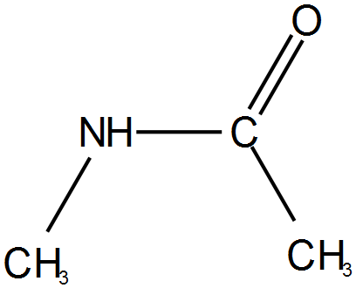

The hydrolysis products of the hydrolysis reaction are:

1. CH3CHO and CH3NH2
2. CH3COOH and CH3NH2
3. CH3COOH and CH3NH
4. CH3CHO and CH3NH



7 Consider this compound:

Its systematic name is:

1. cis-methylpropanal
2. 1-methyl propanal
3. trans-methylpropanal
4. butanal

8 Artificial fruit flavourings are made from synthetic esters. Esters are usually prepared in the

laboratory by the reaction of

1. a carboxylic acid and an aldehyde
2. an aldehyde and an alcohol
3. an aldehyde and an alkyl halide
4. an alcohol and a carboxylic acid

9 The compound CH3CH2CH2COOCH3 has a fragrance similar to that of a

pineapple.

The name of the compound is

1. propyl ethanoate
2. butyl methanoate
3. methyl propanoate
4. methyl butanoate

10. Which compound would have the highest boiling point?

(a) CH3NH2

(b) CH3CH2OH

(c) CH3COCH3

(d) CH3CH = CH2.

11. Which of the following organic compounds would act as a base in water?

1. CH3CH2C
2. CH3CH2OH
3. CH3COOH
4. CH3CH2NH2

12. Ethene (CH2CH2) can be used to manufacture ethyl ethanoate, CH3COOCH2CH3,in three steps, as indicated below:

Step 3

esterification

Step 2

A

Step 1

CH3COOCH2CH3

B

CH2CH2

Which one of the following is the correct sequence of steps 1 and 2?

**Step 1 Step 2**

1. substitution with water oxidation
2. addition of water oxidation
3. oxidation addition of water
4. oxidation substitution with water

13. Which of the following substances does not demonstrate geometric *(cis/trans)*isomerism?

1. but-2-ene
2. pent-2-ene
3. 1,3-dichloropropene
4. 1-chloro-2-methylpropene

14. Which of the pairs of compounds below could be used to make the following molecule?

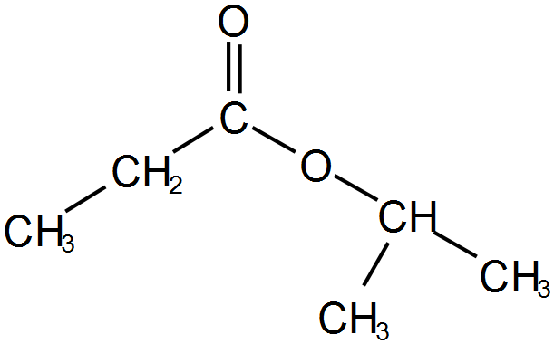

1. Propanoic acid and propan-2-ol
2. Propanoic acid and 2-methylpropanol
3. Ethanoic acid and -propan-2-ol
4. Ethanoic acid and 1-propanol

15 Which one of the following is a pair of isomers?

1. Benzene and cyclohexane
2. But-1-ene and cyclobutane
3. 2,3-dimethyl butane and pentane
4. Hexane and methyl cyclopentane

16. The following molecule ,HOCH2CH2CHO, belongs to two classes of compounds. Which are they?

1. An aldehyde and a primary alcohol
2. An aldehyde and a secondary alcohol
3. A ketone and a primary alcohol
4. A ketone and a secondary alcohol

17 Which one of the following pairs of monomers could be used to produce the polymer shown below?



(a) HOCH2CH2CH2CH2OH and HOOCCH2COOH

(b) CH3CH=CHCH3 and HOOCCOOH

(c) CH3CH(OH)CH(OH)CH3 and HOOCCH2CH2COOH

(d) CH3CH(OH)CH(OH)CH3 and HOOCCH2COOH

18. The monomer used to produce the polymer shown below is:



(a) CHC=CH2.

(b) CHC=CHC.

(c) CH2=CHC-CH2=CHC.

(d) CH2CCH2C.

19. Which of the following reactants are capable of forming a condensation polymer under suitable conditions?

1. HOCH2CH2CH2CH2CH2CH2COOH



(b)



(c)

(d) HOOCCH2CH2CH2CH2CH2CH2CH2COOH

and

HOOCCH2CH2CH2COOH

20. In a series of experiments the following observations were made about a colourless liquid.

|  |  |
| --- | --- |
| **Experiment** | **Observation** |
| Liquid was added to potassium dichromate solution | No visible reaction |
| Liquid was added to sodium metal | Colourless, odourless gas evolved, silvery solid dissolved |
| Liquid was added to ethanol and heated with concentrated sulfuric acid | Fruity smell produced |

Which one of the following substances would produce all of these observations?

(a) 2-methyl-2-butanol

(b) butanoic acid

(c) butan-2-ol

(d) butanone

**YEAR 12 CHEMISTRY**

**TEST 4**

**ORGANIC CHEMISTRY ANSWER BOOKLET**

**STUDENT NAME**

**TEACHER**

**Recommended time: 50 minutes**

**PLEASE:**

* **DO NOT TURN THE PAGE UNTIL INSTRUCTED**

Section one: 20 Multiple- choice questions /20 marks

Section two: 5 Short answer questions /20 marks

Section three: 1 Extended answer question /10

MULTI-CHOICE ANSWER SHEET

Use a blue or black biro to mark the correct answer by shading over the letter (eg. B)

If you change your mind, shade over the letter for the revised correct answer (as above) and place a cross over the deleted answer (eg. C ).

|  |  |  |  |  |  |  |  |  |  |  |  |  |
| --- | --- | --- | --- | --- | --- | --- | --- | --- | --- | --- | --- | --- |
|  |  |  |  |  |  |  |  |  |  |  |  |  |
|  |  |  |  |  |  |  |  |  |  |  |  |  |
| 1 | A | B | C | D |  |  |  |  |  |  |  |  |
| 2 | A | B | C | D |  |  |  |  |  |  |  |  |
| 3 | A | B | C | D |  |  |  |  |  |  |  |  |
| 4 | A | B | C | D |  |  |  |  |  |  |  |  |
| 5 | A | B | C | D |  |  |  |  |  |  |  |  |
| 6 | A | B | C | D |  |  |  |  |  |  |  |  |
| 7 | A | B | C | D |  |  |  |  |  |  |  |  |
| 8 | A | B | C | D |  |  |  |  |  |  |  |  |
| 9 | A | B | C | D |  |  |  |  |  |  |  |  |
| 10 | A | B | C | D |  |  |  |  |  |  |  |  |
| 11 | A | B | C | D |  |  |  |  |  |  |  |  |
| 12 | A | B | C | D |  |  |  |  |  |  |  |  |
| 13 | A | B | C | D |  |  |  |  |  |  |  |  |
| 14 | A | B | C | D |  |  |  |  |  |  |  |  |
| 15 | A | B | C | D |  |  |  |  |  |  |  |  |
| 16 | A | B | C | D |  |  |  |  |  |  |  |  |
| 17 | A | B | C | D |  |  |  |  |  |  |  |  |
| 18 | A | B | C | D |  |  |  |  |  |  |  |  |
| 19 | A | B | C | D |  |  |  |  |  |  |  |  |
| 20 | A | B | C | D |  |  |  |  |  |  |  |  |
|  |  |  |  |  |  |  |  |  |  |  |  |  |

You may use the space for rough working for multi-choice questions

**Section 2: Short Answer.** This section is worth **20 marks**

Answer in the spaces provided.

21. Complete the table below by giving a brief description of a chemical test that could be used

to distinguish between the substances listed.

List the observations relating to the test for each of Substance 1 and Substance 2.

|  |  |  |
| --- | --- | --- |
|  | Description of chemical test | Observation  with substance 1 |
| Substance 1  butan-2-one |  |  |
| Substance 2  Butanal | Observation with substance 2 |
|  |

(3 marks)

22. Draw the structural formulae for the following:

(a) Three (3) structural (positional) isomers of the compound that has the molecular formula C5H10. Show all of the atoms in the structure.

(3 marks)

(b) Two geometric isomers of the compound that has the molecular formula C5H10

(2 marks)

1. A compound is known to be an ester. Its molar mass is 74. 0 g mol-1. Draw two structural

isomers of this compound

(2 marks)

23 Explain why butanoic acid is a solid at room temperature whereas methyl propanoate is a liquid at room temperature. Include simple diagrams in your answer.

(3 marks)

24 Complete the table below by either naming the compound whose structural formula has been given

or using the name of the compound that is given draw the compounds structural formula.

|  |  |
| --- | --- |
| Name | Structural formula |
|  |  |
| 2-ethylbutanamine |  |
|  |  |
| pentanamide |  |

(4 marks)

25. Kevlar is the registered [trademark](https://en.wikipedia.org/wiki/Trademark) for a polyamide that has a high tensile strength to weight ratio, far exceeding steel. It is used in “bullet proof jackets” but is more widely used in aerospace engineering.

The monomers used to make Kevlar are

 and 

Draw the polymer that forms when these two monomers react to to form a polymer. Include two repeating units in your diagram

(3 marks)

**Section 3 Extended answer.** This section is worth **10 marks.**

26. Qualitative analysis of the compound responsible for the unpleasant smell of rancid butter showed it to contain carbon, hydrogen and oxygen. A sample of the compound has a mass of 0.392g and a gaseous volume of 152 mL at 170 °C and 105k Pa. This sample was mixed with excess oxygen and the mixture was sparked. The products of the reaction were 0.320 g of water and 405 mL of carbon dioxide measured at 27.1 °C and 110 kPa. From these results determine:

1. the masses of carbon, hydrogen and oxygen in the sample.
2. the empirical formula of the compound.
3. the molecular mass of the compound.
4. the molecular formula of the compound
5. This compound is extremely soluble in water and will not react with an acidified oxidizing agent. Given this information draw a possible structural formula for the compound and give its IUPAC name.